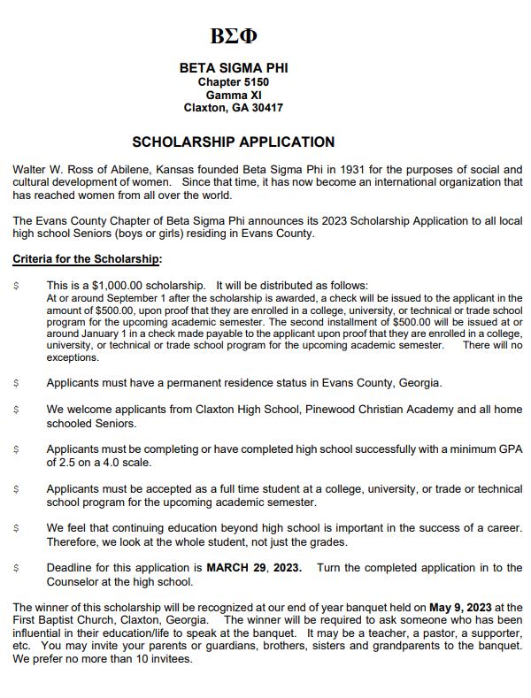
ΒΣΦ

BETA SIGMA PHI
Chapter 5150
Gamma XI
Claxton, GA 30417

SCHOLARSHIP APPLICATION 2023

DEADLINE FOR APPLICATION TO BE
COMPLETED AND TURNED INTO THE SCHOOL 3-29-23

Very Important!

Instructions:
Please print or type in black ink.
Do not reproduce this form other than by copying.
Do not attach anything to this form, i.e. transcript, etc.

YOU MUST LIVE IN EVANS COUNTY TO BE ELIGIBLE FOR THIS SCHOLARSHIP.

Name: Age:

Mailing Address:

Street :

City: State: Zip:

Telephone Number:

Grade Point Average (if known) (on a 4.0 scale):
Class Rank (if known):

ACT Score:
or
SAT Score:

Name of the High School you are attending:

Are you the first person in your family to go to college?

Parent or Legal Guardian Name:
Mailing Address:
Street :
City: State: Zip:

Parent or Legal Guardian Name:
Mailing Address:
Street :
City: State: Zip:

~~~~~~~~~~

Where do you plan to go to college?

When do you plan to start college?

What do you plan on majoring in?

What specialty/major do you plan to major in as you continue your education?

Will you be a full time student?

Will you be a commuting student?

Will you live on campus? If no, where will you be living?

List any academic honors, awards and membership activities while in high school:
Click here to enter text.

List your hobbies, outside interests, extracurricular activities and school related volunteer activities:

Click here to enter text.

List your non-school sponsored volunteer activities in the community.
Click here to enter text.

Is there anything about you or your circumstances that you would like us to know? (optional)
Click here to enter text.

