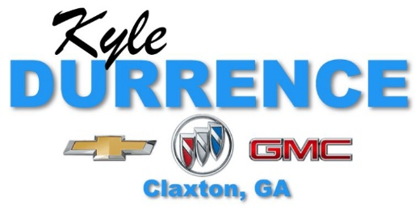
Scholarship Application

Must have participated in a sport, be an active member of an organization that supports community involvement and have at least a 90 average.

Please Attach:
A Resume That Includes All Extracurricular Activities, Honors, And Awards.

Name:

Address:

City: State: Zip:

Date of Birth:

EDUCATION

Diploma Type:

High School GPA: Class Rank: Of

ACT Scores: Reading: English: Math: Science:

SAT Scores: Reading: Math: Writing:

College or Technical School You Plan to Attend:

Proposed College Major or Field of Study:

Career Goals:

EMPLOYMENT

Current Position:

Company Name:

Previous Job(S) Held and Dates:

FAMILY

Father’s Name: Occupation:

Mother’s Name: Occupation:

Number of Siblings: Number of Siblings in College:

COMMUNITY INVOLVEMENT

Church Membership:

Office(S) And Committees:

List any academic or athletic awards and honors:

List all sports, club memberships, community involvement and positions held:

Why should Kyle Durrence Chevrolet choose you for this scholarship?

How will it help you pursue your educational goals?

