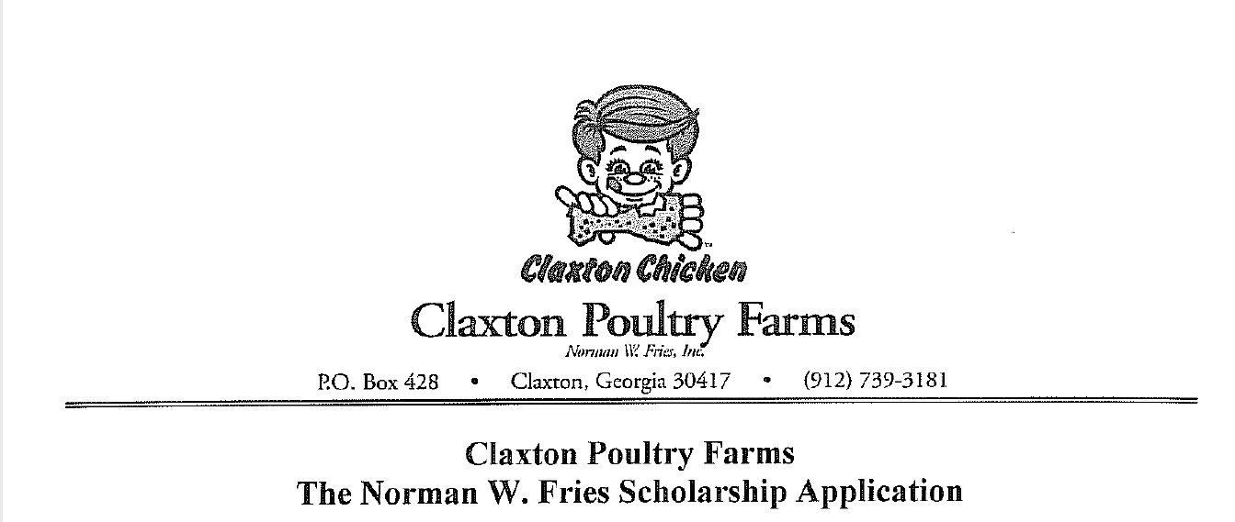
This year marks the twenty-fourth anniversary of the Norman W. Fries College Scholarships, offering high achieving high school seniors $2,000 grants to help further their college education. The rules are simple: you must be a graduating high school senior pursuing a career in health, nutrition, agriculture, or a related science or business degree. You will be asked to demonstrate your academic excellence, leadership skills, community involvement and extracurricular activities that demonstrate focus and commitment
Please type. This application will be reviewed carefully; prepare it as you would an important paper or examination, using additional pages if needed. Make a copy of your application for your file and then submit the original to your guidance or career counselor. If you’re successful you will also be asked to submit a color 3” x 5” (or similar dimension) 2022 school graduation photograph and will be invited to participate in a phone interview and possible other media involvement. Return completed form to your guidance or career counselor by April 4, 2022.
Congratulations on your approaching graduation and best wishes for your continued success!
Name:
High School:
Date and Place of Birth:
Address:
City: State: Zip:
Home Phone Number: Cell Phone Number:
Email:
Personal URL(s) if applicable:

When is the best time to contact you for a brief interview if you are named a Norman W. Fries Scholarship recipient?
Parents Names and briefly describe their work:
List any caregiver, mentors, and/or friends that have been important influences on your life.
Siblings Names and Ages:
Please state the name(s) of all colleges/technical institutions to which you have been accepted and where they are located:
If you have already been accepted, where do you plan to attend and when will you start?
In 300-500 words tell us what your proposed field of study it, why you’ve chosen it and how it supports your career goals and why you think you’re deserving of it:
List any scholarships or other form of financial aid you have been offered, either at your chosen school or elsewhere.
Do you plan to live at or near the school or will you be staying home during your studies?
High School Grade Point Average expressed as a fraction of the highest possible score: (Example: 3.7/4.0)
What was your final class rank?
Highest SAT Score achieved: Highest ACT Score achieved:
What were any other major standardized tests you took and their scores?
List all major academic honors and awards:
List major athletic honors including years of participation, leadership roles and other distinctions:
What were your athletic titles (indicate varsity, junior varsity, or intramural):
List clubs, activities, years served, and any offices held:
List school offices (i.e. student council, etc.), years served and your titles:
Please tell us about your community involvement, including any titles, length of activites and measurable accomplishments:
Detail in chronological order your work experience, including any job titles, description of duties and duration of employment(s):
Please attach your resume if you created one.
Please add any other material facts and other accomplishments you feel should be considered by the scholarship award judges.

Applicant Name: ___________________________________________
Applicant Signature: ________________________________________
Parent Name: ______________________________________________
Parent Signature: ___________________________________________
Date: _____________________________

